BMW Sales Analysis and Dashboard

Abstract
The automotive industry generates large volumes of sales, pricing, and performance data across multiple regions and product variants. Analyzing this data manually is time-consuming and error-prone. This project focuses on the analysis of BMW car sales data using data visualization and business intelligence techniques. A dynamic BMW Sales Dashboard was developed to provide insights into sales performance, pricing trends, mileage patterns, regional demand, and model-wise contribution. The dashboard helps stakeholders quickly understand key performance indicators (KPIs) such as total sales, total price, average mileage, and average sales. The project demonstrates how data analytics tools can support data-driven decision-making in the automobile sector.

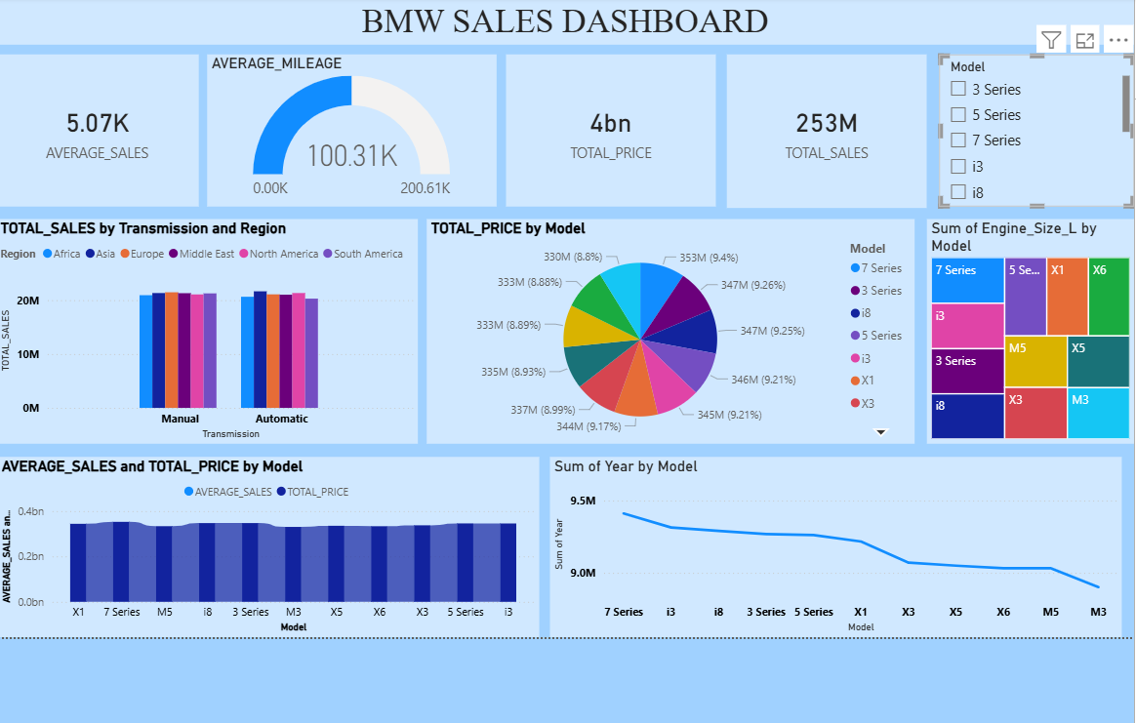

1. Introduction
In today’s competitive automobile market, companies like BMW rely heavily on data to understand customer preferences, market demand, and operational performance. Sales data analysis enables organizations to evaluate which models perform well, identify regional demand variations, and optimize pricing strategies.
This final year project aims to analyze BMW sales data and present the insights using an interactive dashboard. The dashboard allows users to filter data by model, transmission type, and region, enabling better understanding of sales trends and performance metrics.

2. Objectives of the Project
The main objectives of this project are:
- To analyze BMW sales data across different models and regions
- To calculate and visualize key performance indicators (KPIs)
- To compare sales based on transmission type (Manual vs Automatic)
- To identify high-performing and low-performing BMW models
- To build an interactive dashboard for business insights

3. Dataset Summary
The dataset used in this project contains structured sales information of BMW vehicles. Each record represents sales data for a specific BMW model with associated attributes.

3.1 Dataset Attributes
The dataset includes the following key columns:
- Model: BMW car models (3 Series, 5 Series, 7 Series, i3, i8, X1, X3, X5, X6, M3, M5)
- Year: Manufacturing or sales year of the vehicle
- Price: Selling price of the vehicle
- Sales: Number of units sold
- Mileage: Average mileage of the vehicle
- Engine Size (L): Engine capacity in liters
- Transmission: Manual or Automatic
- Region: Sales region (Africa, Asia, Europe, Middle East, North America, South America)

3.2 Data Pre-processing
Before creating the dashboard, the following steps were performed:
- Removal of missing and duplicate values
- Data type validation for numeric and categorical columns
- Creation of calculated fields such as total sales and average values
- Standardization of region and model names

4. Tools and Technologies Used
- Data Visualization Tool: Power BI
- Data Source: BMW Sales Dataset (CSV/Excel)
- Platform: Windows OS
- Techniques Used: Data aggregation, filtering, KPI calculation, visual analytics

5. Key Performance Indicators (KPI) Explanation

5.1 Average Sales
- Value Displayed: 5.07K
- Description: Represents the average number of units sold across all BMW models.
- Business Insight: Helps evaluate overall market demand consistency.

5.2 Average Mileage
- Value Displayed: 100.31K
- Description: Shows the average mileage of BMW vehicles.
- Business Insight: Indicates fuel efficiency trends and customer preference for mileage.

5.3 Total Price
- Value Displayed: 4 Billion
- Description: Sum of prices of all vehicles sold.
- Business Insight: Represents total revenue generated from sales.

5.4 Total Sales
- Value Displayed: 253 Million
- Description: Total number of vehicles sold across all models and regions.
- Business Insight: Measures overall business volume and market reach.

6. Dashboard Analysis

6.1 Total Sales by Transmission and Region
This visualization compares manual and automatic transmission sales across different regions.
- Automatic transmission vehicles show slightly higher sales in most regions.
- Asia and Europe contribute significantly to total sales.

6.2 Total Price by Model
The pie chart represents the contribution of each BMW model to the total price.
- Models like 7 Series, 5 Series, and X Series contribute a major share of revenue.
- Premium models generate higher revenue despite lower sales volume.

6.3 Sum of Engine Size by Model
This treemap shows engine size distribution across BMW models.
- Larger engine sizes are associated with X and M series.
- Smaller engine sizes are seen in i-series models.

6.4 Average Sales and Total Price by Model
This bar chart compares average sales and total price for each model.
- Entry-level models show higher sales volume.
- Luxury models show higher pricing impact.

6.5 Sum of Year by Model
This line chart displays sales trend by year and model.
- 7 Series and i3 show consistent performance over time.
- Some models show a gradual decline, indicating changing market trends.

7. System Architecture
The system architecture consists of the following components:
- Data Source (BMW Sales Dataset)
- Data Cleaning and Processing
- Data Modeling and KPI Calculation
- Dashboard Visualization Layer
- User Interaction and Filters

8. Advantages of the System
- Interactive and user-friendly dashboard
- Quick decision-making using visual insights
- Easy comparison of models and regions
- Reduces manual analysis effort

9. Limitations
- Dataset is limited to available historical data
- Real-time data integration is not implemented
- External market factors are not considered

10. Future Scope
- Integration of real-time sales data
- Predictive analytics for future sales forecasting
- Customer segmentation analysis
- Comparison with competitor brands
- Deployment of dashboard on cloud platform

11. Results and Findings
From the analysis of the BMW Sales Dashboard, several important results and findings were observed:
- Automatic transmission vehicles contribute higher sales compared to manual transmission in most regions.
- Europe and Asia are the strongest markets for BMW sales, indicating higher demand and brand presence.
- Premium models such as the 7 Series, X Series, and M Series generate higher revenue despite comparatively lower sales volume.
- Electric and hybrid models like i3 and i8 show consistent but moderate sales, highlighting gradual adoption of eco-friendly vehicles.
- Engine size has a direct relationship with pricing, where higher engine capacity models contribute more to total price.
These findings can help management optimize pricing, production planning, and regional marketing strategies.

12. Business Use Cases
The BMW Sales Dashboard can be used in multiple real-world business scenarios:
- Sales Strategy Planning: Identify high-performing models and focus marketing efforts accordingly.
- Regional Performance Analysis: Allocate resources to regions with higher growth potential.
- Product Portfolio Optimization: Decide which models to promote, upgrade, or discontinue.
- Revenue Forecasting: Use historical trends to estimate future revenue.
- Management Reporting: Provide quick insights to executives using visual dashboards.

13. Data Flow Diagram (DFD) Description

Level 0 DFD (Context Diagram)
- The system takes BMW sales data as input.
- Data is processed using BI tools.
- Output is an interactive sales dashboard for users.

Level 1 DFD
- Data Collection from Excel/CSV files
- Data Cleaning and Transformation
- KPI Calculation
- Visualization and Dashboard Generation

14. Methodology
The project follows a structured data analytics methodology:
- Requirement Analysis
- Data Collection
- Data Cleaning and Preprocessing
- Data Modeling
- KPI Definition
- Dashboard Design
- Testing and Validation
- Result Interpretation

15. Testing and Validation
To ensure accuracy and reliability, the following testing methods were used:
- Validation of KPI calculations using sample data
- Cross-checking totals and averages
- Filter testing for models, regions, and transmission types
- User acceptance testing to ensure dashboard usability

16. Conclusion
This project successfully demonstrates the use of data analytics and visualization in understanding BMW sales performance. The BMW Sales Dashboard provides meaningful insights into sales trends, revenue contribution, and customer preferences. Such dashboards can significantly help management in strategic planning and decision-making. The project highlights the importance of business intelligence tools in the modern automobile industry.

12. References
- BMW Official Website
- Power BI Documentation
- Data Visualization and Business Intelligence Resources

